Day 10

**Day 10**

Create the view products status. Show year wise total products sold. Also find the percentage of total value for each year. The output should look as shown in below figure.

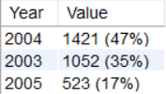

Ans)

Tables was not mentioned hence, used these tables: orders, orderdetails

